**Activities -CSS chapter 2**

* You are creating a simple task list with HTML and styling it using CSS. The CSS file resets the default list styles and then adds custom styles to the list items.

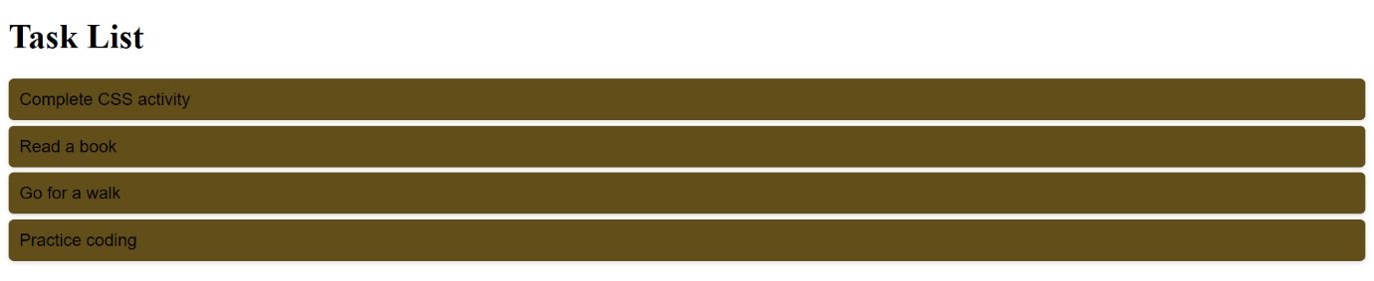

* How can you style hyperlink using CSS to make them visually appealing and responsive to user interactions. Create a simple webpage with a hyperlink and styling it using CSS.

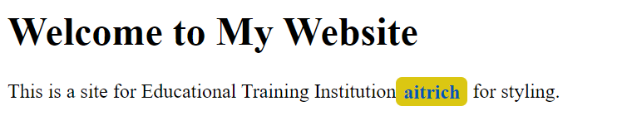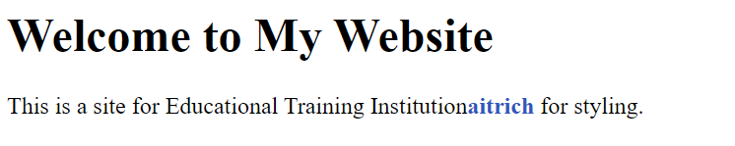

* How can you enhance the visual appeal and interactivity of an HTML table using CSS styles.

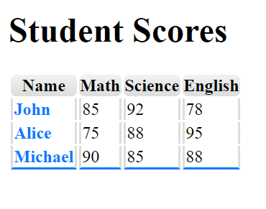

* Using CSS to create a box model and style it.

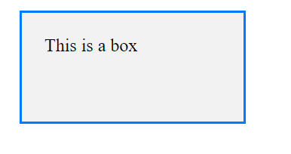

* In this activity, you will practice styling images using CSS to add visual enhancements and create a better presentation on a webpage.

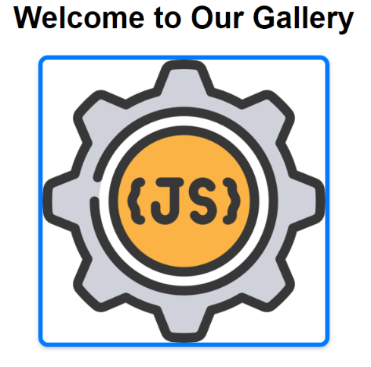

* Using border styling in CSS to complete this activity

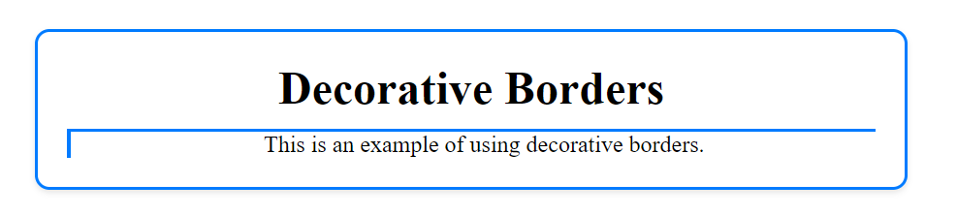

* Using CSS to style these pages using all style properties like list, image, hyperlink, border, box model and table



